The “Anti-Maranza” Bill: Security as Electoral Technology

A game-theoretical model of punitive signalling, moral panic and the political production of obedience
By Davide Scuteri Moretti
The principal output of punitive politics is not necessarily security. Often it is the publicly observable production of authority.

Abstract
The Italian bill informally labelled “anti-maranza”, approved by the Council of Ministers on 14 July 2026, has been presented as a response to youth violence and social disorder. Its most visible provisions include the extension of preventive detention to minors in specified public-order operations, aggregation bans, and harsher treatment of group damage and knife-related conduct. The political meaning of the package, however, cannot be inferred from its legal text alone. It must be reconstructed as a strategic interaction among government, voters, media, police institutions, adolescents and socially marked minorities.
This article argues that the bill functions primarily as an electoral reassurance technology. It converts a complex and uneven social phenomenon into a low-dimensional signal—the state is once again willing to punish—whose electoral observability is much higher than that of education, welfare, urban mediation or family support. Using signalling games, Bayesian updating, prospect theory, repeated games, mechanism design, feedback systems and a simple functional-analytic representation of public anxiety, I show why a government may rationally prefer a highly visible coercive policy even when its expected marginal contribution to objective safety is uncertain or inferior to that of preventive social investment.
The claim is not that youth crime is imaginary. Some offences and some territories display real and sometimes serious increases. The claim is narrower and more demanding: heterogeneous increases do not establish a nationwide social emergency, and the existence of a problem does not prove the effectiveness, proportionality or necessity of the chosen instrument. The “anti-maranza” label is therefore analytically revealing. It does not identify a legal offence; it manufactures a socially recognisable type. Punitive policy then moves from governing actions to governing appearances, gatherings and presumed dispositions.

1. From a legislative instrument to a political signal
Technically, the measure is a bill, not an operative decree. The distinction matters. Yet the political payoff begins before parliamentary approval. Announcement itself is an intervention in the informational environment.
Let the government choose between two stylised strategies:
[ a_G {P,R} ]
where (P) denotes preventive social policy and (R) denotes visible repression. Let the government’s utility be:
[ U_G(a_G)=V(a_G)+S(a_G)+M(a_G)-C(a_G)-L(a_G) ]
with:
- (V): expected electoral votes;
- (S): objective public-safety improvement;
- (M): media visibility and agenda control;
- (C): fiscal and administrative cost;
- (L): expected legal, constitutional and reputational loss;
- (,,,): political weights.
Preventive policy may have the larger long-run safety effect:
[ S(P)>S(R), ]
while repression has the larger short-run visibility:
[ M(R)M(P). ]
If an election is sufficiently close, the government discounts future benefits at rate (). Its intertemporal payoff becomes:
[ U_G=_{t=0}^{{T}}t, <<1. ]
With a short electoral horizon, () is politically small: a school programme producing results in five years has less present value than a police operation producing images tonight. Repression can therefore be electorally optimal without being socially optimal.
That is the first analytical distinction:
[ {a}U_G(a) {a}W(a), ]
where (W) is aggregate social welfare.

2. The multi-player game
The relevant game has at least five classes of players:
[ N={G,E,M,I,Y}, ]
where (G) is government, (E) the electorate, (M) the media system, (I) coercive institutions and (Y) young people. Each player optimises a different objective.
Player | Primary payoff | Information advantage | Typical strategy
Government | Votes, agenda control, authority | Access to policy design and aggregate data | Announce, punish, invest, frame
Electorate | Felt safety, normative stability | Private fear; limited causal data | Reward, punish, demand control
Media | Attention, retention, emotional intensity | Selection of salient events | Amplify, personalise, serialise
Police institutions | Resources, mandate, operational discretion | Street-level information | Enforce, classify, deter
Young people | Autonomy, status, belonging, opportunity | Local peer-network knowledge | Comply, evade, signal, resist
The social optimum requires coordination among schools, welfare services, municipalities, families, cultural institutions and law enforcement. The electoral optimum requires a legible gesture. The bill reduces a high-dimensional coordination problem to a binary public message:
[ ; / ; . ]
This compression is politically useful precisely because it destroys information.

3. Bayesian voters and the manufacture of reassurance
Voters do not observe the government’s true capacity or intentions. They observe signals. Suppose the government has an unobservable type:
[ _G{H,L}, ]
where (H) denotes “high capacity to impose order” and (L) denotes “low capacity”. The electorate begins with prior belief:
[ (_G=H)=. ]
After observing a punitive bill (R), voters update according to Bayes’ rule:
[ (HR)= {(RH)+(RL)(1-)}. ]
The bill is electorally useful whenever voters believe that a “strong” government is more likely to choose repression:
[ (RH)>(RL). ]
But this inference may be false. A low-capacity government may be more dependent on theatrical coercion because it cannot produce complex social outcomes. The signal can therefore become semi-pooling or deceptive: both capable and incapable governments select (R), and its informational value approaches zero.
The voter nevertheless experiences reassurance because affective updating is not identical to Bayesian accuracy. We may represent perceived safety as:
[ _E = S^{*}+q+m-d, ]
where (S^{*}) is objective safety, (q) is the observed quantity of coercive action, (m) is message repetition and (d) is experienced disorder. If () and () are sufficiently large, perceived safety can rise while objective safety remains unchanged:
[ _E>0 S^{*}. ]
This is not a marginal side effect. It is the policy’s most immediate deliverable.

4. A payoff matrix: why visible punishment dominates
Consider a simplified interaction between government and an anxious electorate. The government chooses prevention (P) or repression (R); voters process policy either analytically (A) or heuristically (H).
 | Voters: analytical processing (A) | Voters: heuristic processing (H)
Government: prevention (P) | ((4,4)) | ((1,2))
Government: repression (R) | ((2,1)) | ((5,4))
The first value is the government’s payoff; the second is the electorate’s perceived payoff. If media architecture makes heuristic processing more probable than analytical processing, the government maximises expected utility through (R):
[ EU_G(R)=p_A(2)+p_H(5), ]
[ EU_G(P)=p_A(4)+p_H(1). ]
Repression is preferred when:
[ 2p_A+5p_H>4p_A+p_H, ]
and because (p_A+p_H=1):
[ p_H>. ]
In other words, visible repression becomes the rational electoral strategy as soon as more than one third of relevant political processing is heuristic under these illustrative payoffs. The numbers are not estimates; they expose the structural mechanism. A political communication system dominated by salience, repetition and loss aversion lowers the threshold further.

5. Prospect theory and the ageing electorate
The target voter does not calculate expected crime losses linearly. Prospect theory models value relative to a reference point:
[ v(x)=
>1,;0<<1. ]
Here () represents loss aversion. A perceived loss of normative control—young people occupying public space, unfamiliar clothing, slang, noise, visible ethnic diversity—can weigh more heavily than an equivalent gain in social vitality or freedom.
Probability weighting further magnifies rare but emotionally available events:
[ w(p)= {(p^{{}+(1-p)}{})^{1/}}, <<1. ]
For small probabilities, (w(p)>p). A single violent episode, repeatedly televised, may therefore acquire a subjective probability much greater than its statistical frequency. Political entrepreneurs do not need to falsify the event. They need only optimise its salience.
Age does not mechanically produce authoritarian preferences, and an older electorate must not be treated as homogeneous. Yet a voter whose reference point is an earlier normative order may experience rapid cultural change as a sequence of losses. The political offer then becomes not merely “less crime” but “restoration of a legible hierarchy”.
Let normative reassurance be:
[ R_N=_1 O+_2 C+_3 H-_4 D, ]
where (O) is visible order, (C) conformity, (H) hierarchy and (D) diversity perceived as unpredictability. The coercive package maximises (R_N) even if its effect on crime (S^{*}) is ambiguous.

6. The moral-panic conversion funnel
The electoral mechanism can be represented as a conversion funnel:
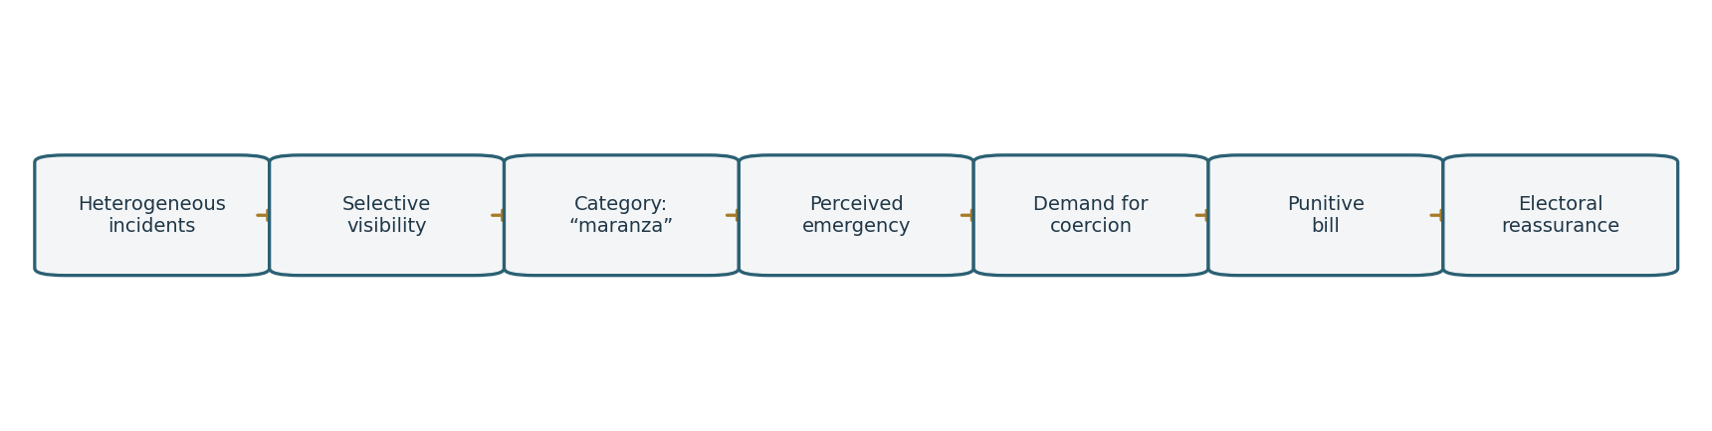
Figure 1. The moral-panic conversion funnel.
Let (n_0) be the number of incidents entering the attention system. At each stage, a transformation rate (r_i) determines political conversion:
[ n_{i+1}=r_i n_i, i=0,,5. ]
Unlike a commercial funnel, amplification may make (r_i>1): one event can generate hundreds of stories, clips, comments and parliamentary statements. The final reassurance yield is:
[ Y_R=n_0_{i=0}^{5}r_i. ]
The government need not increase (n_0). It can improve conversion by naming the category, repeating the frame and supplying a punitive endpoint. “Maranza” is therefore not an innocent description; it is a classification technology that raises (r_2) and (r_3).

7. From acts to types: the political mathematics of stigma
Criminal law is ideally action-centred: sanction follows a defined act. Moral panic is type-centred: suspicion follows a cluster of observable markers.
Let each person be represented by a feature vector:
[ x=(x_1,x_2,,x_n)^n, ]
including clothing, age, location, group size, language, ethnicity as perceived by others, prior police contact and behaviour. Public-order practice implicitly constructs a risk score:
[ z(x)=(b+_{j=1}^{n}w_jx_j), (t)=. ]
Intervention follows when:
[ z(x)>. ]
Lowering the threshold () increases sensitivity but also false positives. If (Y=1) denotes genuinely dangerous conduct, the social cost is:
[ C()=c_{FN}(z,Y=1)+c_{FP}(z>,Y=0). ]
Punitive politics systematically underprices (c_{FP}), the cost of treating a harmless young person as dangerous. That cost is dispersed, frequently borne by minorities and rarely converted into votes. By contrast, a false negative attached to a spectacular crime has concentrated media cost. The politically optimal threshold (_G) is therefore lower than the socially optimal threshold (_W):
[ _G<_W. ]
This is how anti-conformism becomes a risk variable and diversity becomes an operational proxy. No statute needs explicitly to criminalise clothing or origin. Selective enforcement can embed those weights in practice.

8. Functional analysis of public anxiety
Public anxiety is not a scalar generated by crime counts alone. It is a functional of an information field.
Let (I(t,s)) denote the intensity of crime-related information at time (t) and social location (s). Define collective anxiety as:
[ [I]= {}{0}^{T} K(T-t,s),(I(t,s)),dt,d(s), ]
where:
- (K) is a memory-and-proximity kernel;
- () is a nonlinear salience transformation;
- () weights demographic groups and media environments.
If (’’(I)>0), repeated intense exposure produces more than proportional anxiety. If the kernel decays slowly for vivid events, one episode continues to affect political demand long after the immediate risk has disappeared.
Policy communication acts as an operator (_G) on the information field:
[ I_{t+1}=_G(I_t)+_t. ]
The system may converge to a fixed point (I^{*}):
[ I^{*}=_G(I^{*}), ]
at which “emergency” becomes the stable interpretive equilibrium. If the spectral radius of the linearised operator satisfies
[ r(DG|{I^{*}})>1, ]
small disturbances are amplified rather than damped. The political system becomes an anxiety multiplier.

9. The self-reinforcing equilibrium
The feedback mechanism is straightforward:
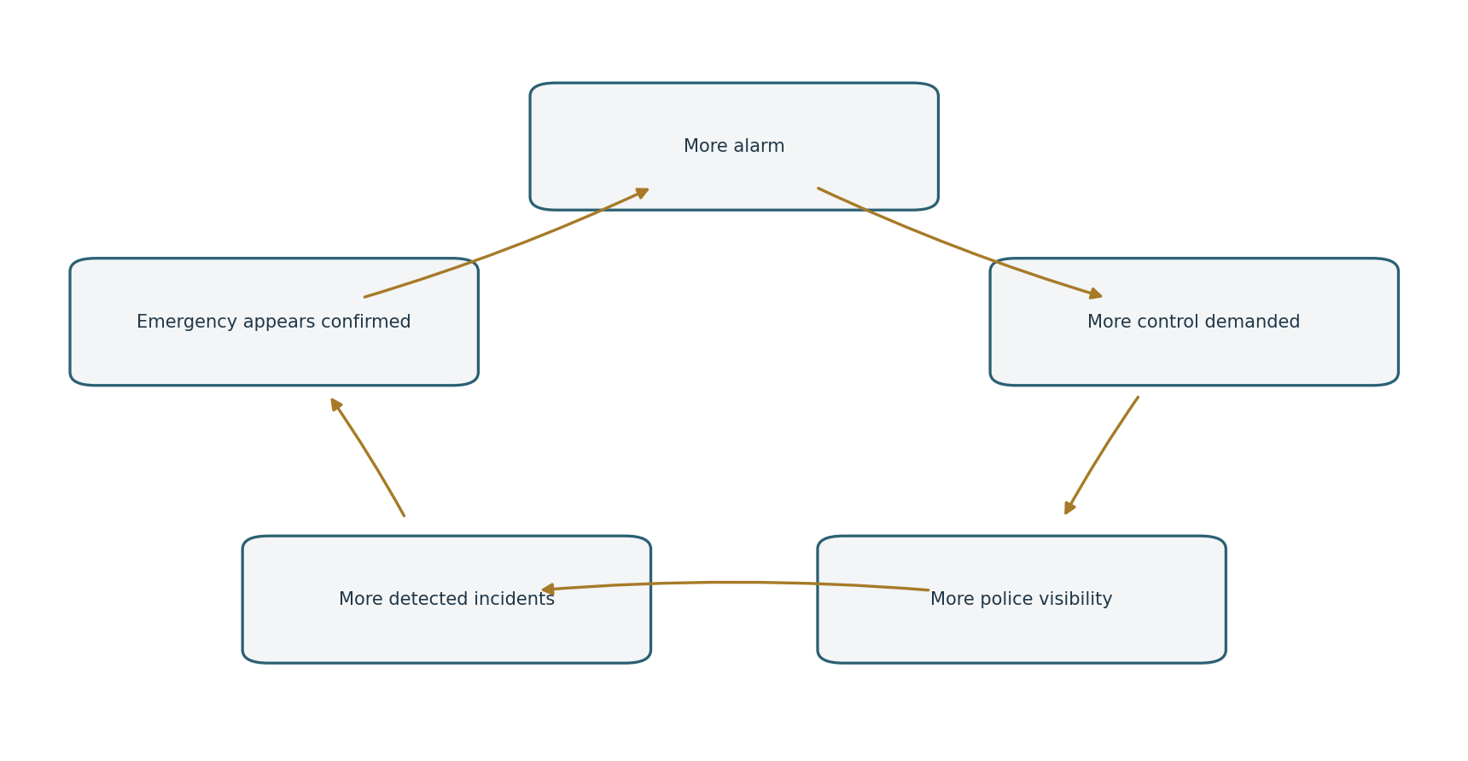
Figure 2. A self-reinforcing equilibrium of alarm and coercive visibility.
Let perceived disorder evolve according to:
[ D_{t+1}=aD_t+bM_t+cQ_t-dS_t+_t, ]
where (M_t) is media amplification, (Q_t) coercive visibility and (S_t) actual safety. The apparently paradoxical positive coefficient (c) reflects the fact that more controls generate more recorded encounters and make disorder more publicly visible.
Government response is:
[ Q_{t+1}=(D_t), ’>0. ]
Substitution gives a recursive system. If
[ a+c’(D)>1, ]
the equilibrium is locally unstable: each punitive intervention increases the informational conditions for the next one. The policy can fail at reducing underlying harm while succeeding at reproducing its political necessity.

10. The social-policy prisoner’s dilemma
Local actors face a coordination problem. Schools, municipalities, health services and families benefit from joint investment, but each bears immediate costs and can free-ride on others.
 | Municipality invests | Municipality defects
School invests | ((4,4)) | ((1,3))
School defects | ((3,1)) | ((2,2))
The preventive optimum is mutual investment ((4,4)), but fragmented budgets and electoral time inconsistency can produce mutual defection ((2,2)). Police action then enters as a substitute for failed coordination. It does not solve the underlying game; it manages its visible residues.
A serious youth policy would alter the payoff structure through binding co-financing, shared outcome metrics and repeated-game incentives. If future cooperation is valued at discount factor (), cooperation can be sustained when:
[ T+, ]
or:
[ , ]
where (R) is the reward for cooperation, (T) the temptation to defect and (P) the punishment payoff. Punitive legislation avoids this institution-building problem by changing the subject from coordination to blame.

11. Data, emergency and the problem of causal inference
The factual argument must remain precise. Italian data show neither a perfectly flat trend nor a uniform collapse into violence. Some reported offences involving minors increased, and specific cities or offence categories require targeted attention. At the same time, Italy remains comparatively low in juvenile offending within Europe, while property offences constitute a large part of the minor-justice caseload. Heterogeneity is the central fact.
An emergency claim cannot be inferred from:
[ C_t>0 ]
alone, where (C_t) is recorded crime. Recorded crime is produced by:
[ C_t=f(B_t,R_t,E_t,L_t,P_t), ]
with (B_t) underlying behaviour, (R_t) reporting propensity, (E_t) enforcement intensity, (L_t) legal classification and (P_t) population composition. An observed rise can reflect changes in more than one component.
Nor does the existence of a rise prove that the proposed policy will reduce it. The relevant estimand is not the before-and-after difference but the average treatment effect:
[ ATE=[Y(1)-Y(0)], ]
where (Y(1)) is crime under the policy and (Y(0)) crime under the counterfactual absence of the policy. Since (Y(0)) is unobserved, credible evaluation requires a design: difference-in-differences, synthetic controls, regression discontinuity or another defensible identification strategy.
For a difference-in-differences design:
[ {DiD}= ({Y}{T,post}-{Y}{T,pre})- ({Y}{C,post}-{Y}_{C,pre}). ]
The bill’s political communication presents punishment as causally self-validating before any such estimate exists. This is policy by iconography.

12. Mechanism design: what is the bill actually optimising?
Good mechanism design begins with an objective function. If the objective is lower victimisation, we might minimise:
[ J_1=[H]+lambda_1 C_{policy}+2 R{rights}, ]
where (H) is harm and (R_{rights}) is rights impairment.
If the objective is electoral reassurance, the function changes:
[ J_2=-V_{reassurance}+3 C{visible}+4 L{political}. ]
The two objectives generate different instruments. Social prevention, targeted policing and evaluation are plausible minimisers of (J_1). Broadly communicable restrictions, preventive powers and symbolic labels are plausible minimisers of (J_2).
The design features of the “anti-maranza” package are easier to explain under (J_2) than under (J_1). This does not prove bad faith. Institutions often select politically measurable outputs because genuine outcomes are delayed and causally noisy. But the distinction should be made explicit.

13. Freedom as a variable in the government’s objective function
The most consequential effect may be cultural rather than penal. The bill communicates a change in the shadow price of freedom.
Let social welfare be:
[ W=S+F+I+T-H, ]
where (F) is freedom, (I) inclusion, (T) institutional trust and (H) social harm. A liberal-democratic system assigns positive weights to all four goods. Punitive normativism behaves as though:
[ ,, , ]
with visible order (O) treated as a dominant political good.
Once the electorate rewards restrictions as evidence of care, governments acquire an incentive to supply further restrictions. Freedom becomes electorally expensive because its benefits are diffuse, while every visible disorder is booked as its concentrated cost.
This is a ratchet effect. Let (r_t) be the level of restriction:
[ r_{t+1}=r_t+{0,A_t-R_t^{opp}}, ]
where (A_t) is public anxiety and (R_t^{opp}) organised resistance. Restrictions rise quickly after salient events but rarely return symmetrically to their prior level. The state remembers every emergency institutionally, even when citizens forget the event that produced it.

14. An alternative policy portfolio
Rejecting theatrical repression does not require denying harm. It requires optimising a different portfolio.
Let policy investment be:
[ x=(x_e,x_w,x_u,x_p,x_m), ]
representing education, welfare, urban design, proportionate policing and mediation. Choose (x) to minimise expected harm:
[ x ; [H(x)]+C(x)+R{rights}(x) ]
subject to:
[ _i x_iB, x_i. ]
The first-order condition for an interior optimum is:
[ - = +. ]
This framework forces policymakers to compare marginal effects instead of comparing moral postures. It asks how many assaults, robberies or repeat offences each euro prevents, at what rights cost and over what time horizon.
A defensible programme would include:
- geographically targeted interventions rather than a nationalised moral category;
- published baseline and outcome indicators;
- independent evaluation with explicit counterfactuals;
- sunset clauses for exceptional preventive powers;
- monitoring of false positives and demographic disparities;
- joint budgets linking schools, welfare services and municipalities;
- policing concentrated on conduct and weapons, not style or social identity.

15. Conclusion: the electoral productivity of a stopped boy
The “anti-maranza” bill should be read as part of a broader transition from social policy to behavioural normativism. Its political promise is not simply that fewer crimes will occur. It promises that authority will again become visible, youth less autonomous, public space more supervised and social difference less institutionally indulged.
In game-theoretical terms, the government is not playing only against offenders. It is playing a signalling game with an electorate, a coordination game with institutions, an attention game with the media and a classification game with society. Repression wins because it is immediate, observable and narratively compressible. Prevention loses because its causal chain is long, its successes are mostly invisible and its beneficiaries possess less electoral power.
The resulting equilibrium is politically efficient and socially dangerous:
[ . ]
This equilibrium prepares the public for a society that is less free, less inclusive and more prescriptive—not necessarily because restriction produces safety, but because restriction itself is sold as proof that government is governing. Diversity becomes uncertainty; uncertainty becomes risk; risk becomes suspicion; suspicion legitimises intervention.
The final asymmetry is brutal and electorally rational. A young person helped by a school, a social worker or a neighbourhood institution is statistically absorbed into ordinary life. He produces no headline and no spectacle of sovereignty. A young person stopped by police produces an image, a message and a political dividend.
In the electoral game, a stopped boy is worth more than a helped one.

Methodological note
The mathematical structures in this essay are explanatory models, not econometric estimates. Their parameters have not been fitted to individual-level voter or crime data. Numerical payoff matrices are illustrative and make strategic assumptions transparent; they should not be misread as measured utilities. The empirical proposition is correspondingly limited: available evidence supports concern about specific offences and local patterns, but not the automatic inference of a homogeneous national emergency or the causal effectiveness of the bill’s most visible coercive measures.

Sources
- Italian Government, “Council of Ministers Press Release No. 181”, 14 July 2026: https://www.governo.it/it/articolo/comunicato-stampa-del-consiglio-dei-ministri-n-181/32336
- Italian Ministry of the Interior, “Juvenile Crime” data and reports: https://www.interno.gov.it/it/stampa-e-comunicazione/dati-e-statistiche/criminalita-minorile
- Italian Ministry of Justice, juvenile justice statistics: https://www.giustizia.it/giustizia/page/it/statistiche?selectedNode=0_6_3
- Save the Children Italia, comparative overview of juvenile offending, 12 March 2026: https://www.savethechildren.it/press/minori-litalia-e-uno-dei-paesi-con-il-tasso-di-criminalita-minorile-tra-i-piu-bassi-europa-ma

